Linux command
Touch : create the file
Vi : editing (I :insert / :wq! : to escape )
Cat : Read the content
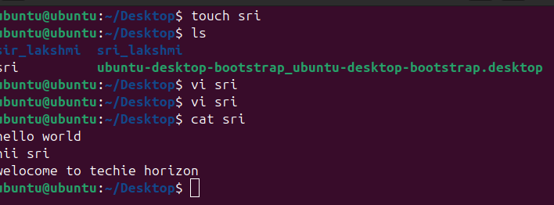
ll : list of flie
ls -ltr - total files
ls -a : show the hidden files
ls -la : hidden file + lone term files
ls -ls : sorting files
su : switch to different user
clear : clear all
rm : remove the files
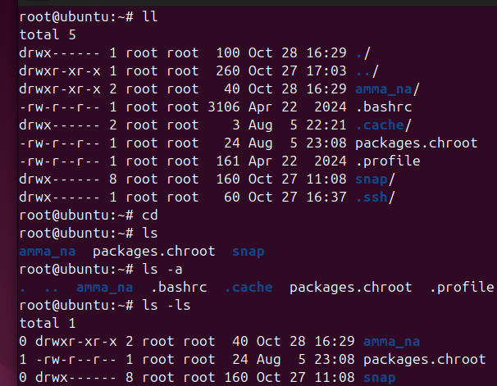
Whoami : which user you are currently logging
Mv : Rename the file
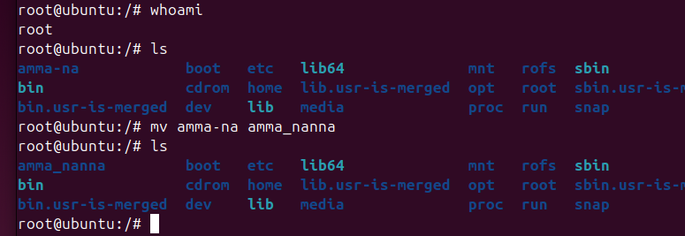
Date : show the date
Time : show the time
History : show the history
